**Math 120  
2.4 Quadratic Equations**

# **Objectives:**

1. Solve quadratic equations by factoring.
2. Solve quadratic equations by the square root property.
3. Solve quadratic equations using the quadratic formula.
4. Determine the most efficient method to use when solving a quadratic equation.
5. Solve problems modeled by quadratic equations.

# **Topic #1: Solving Quadratic Equations by Factoring**

Quadratic equations are in the general form:

$$ax^{2}+bx+c=0;a≠0$$

In certain cases, the quadratic can be factored and the **_______________________** can be applied:

If factors $A*B=0$, then $A=0$ or $B=0$

In other words, if two factors multiply to make zero then set each factor to zero and solve. This is true since any number times zero is zero. In order to apply the rule, the quadratic should be in general form and then factored. *Note: not all quadratics can be factored nicely, this only works in special cases.*

*Example #1* – Solve the Quadratic Equation by Factoring

a. $\left(x-7\right)\left(2x+1\right)=0$

This is already factored, set each factor to zero and solve:

b. $x^{2}-3x-54=0$

This is in general form, but needs to be factored:

Set each factor to zero and solve:

c. $4x^{2}-2x=0$

This is in general form, but needs to be factored:

Set each factor to zero and solve:

d. $x^{2}=6x+27$

This is not in general form, bring terms over to set equal to 0:

Factor:

Solve:

# **Topic #2: Solving Quadratic Equations by the Square Root Property**

The square root property states:

If $a^{2}=b$, then $a=±\sqrt{b}$

In other words, a square root undoes a square and there are two roots. Notice when taking a square root there is a ____________________________________________; the only exception is the square root of ZERO, which is just ZERO. Since all quadratics involve a square term, all quadratic equations can be solved with this property (we will take a more detailed look at this later).

*Example #1* – Solve the Quadratic Equation by the Square Root Property

a. $x^{2}=63$

The square term is isolated; apply the property, and factor out the perfect square to simplify:

b. $4x^{2}+3=43$

The square term is not isolated.

Note: there are no perfect squares to factor out. Also, we could write the solution as $x=$

c. $2x^{2}-4=-102$

The square term is not isolated.

Note: the solution is a complex number since the square root of a negative number is not defined by real numbers.

d. ${\left(x-1\right)}^{2}=81$

The square term is a binomial (but isolated nonetheless); apply the property:

e. $2{\left(x+3\right)}^{2}=16$

The square term is not isolated:

# **Topic #3: Solving Quadratic Equations with the Quadratic Formula**

As stated before, quadratic equations are in the general form: $ax^{2}+bx+c=0;a≠0$

The **quadratic formula** solves the general form above by completing the square and applying the square root property. The result is the solution to any quadratic equation in general form:

*Example #1* – Solve the Equation with the Quadratic Formula

a. $2x^{2}-9x-2=0$

This is in form, where $a= b= c=$

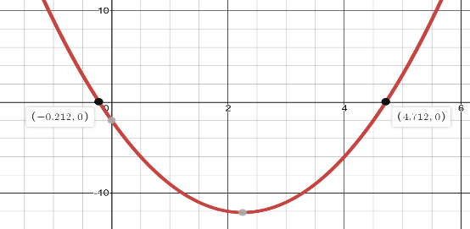The decimal approximations above give $x≈$

and a graph confirms the solution!

b. $x^{2}-12x+72=0$

This is in form, where $a= b= c=$

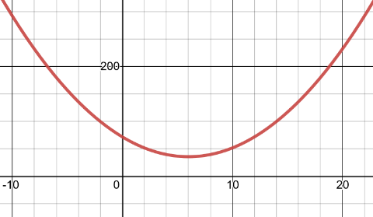

This is a complex solution, factor out $i$, and simplify:

A graph confirms there is not a real solution since the quadratic does not intersect the $x-$ axis.

c. $\left(5x+2\right)\left(x+1\right)=1$

This is not in general form, FOIL, and set equal to 0:

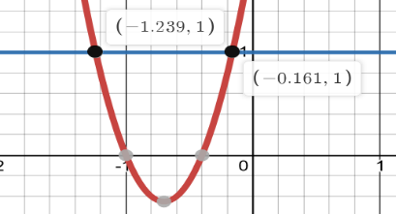This is in form now, where $a=5, b=7, c=1$:

The decimal approximations above give $x≈$ and a graph confirms the solution! The graph shows the intersection of the curves from the original equation.

*Example #2* – Build a Quadratic Equation and Solve

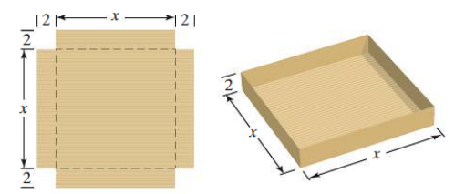A machine produces open boxes using square sheets of metal. The machine cuts equal sized 2-inch squares from each corner of the sheet and then shapes the metal into an open box by folding up the sides. The figure illustrates the process.

a. Write a function that express the volume of the box as function of the length and width of the box.

b. Suppose the box is specified to have a volume of 450 cubic inches. Find the length and width of the box.

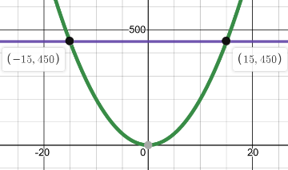

Since length and width cannot be negative, we use the principal root. The length and width are:

A graph can be used to show the solution too.

**Topic #5: Choosing the Easiest Method**

Sometimes there is an easiest method to solving a quadratic function.

Below, look at each quadratic equation and choose the easiest method to solve: Factoring, Square Root Property, or Quadratic Equation. DO NOT SOLVE.

a. ${9x}^{2}-6x-7=0$

b. ${2x}^{2}+12x=-32$

c. ${\left(3x-2\right)}^{2}-5=0$

d. $2x^{2}-4=-102$

e. $x^{2}+7x+12=0$

f. $9x^{2}-25=0$

**Topic #6: $x$-Intercepts and Zeros of a Quadratic Function**

Quadratic functions are in the form: $f\left(x\right)=ax^{2}+bx+c;a≠0$.

The **_________________** of a quadratic function **occur where the curve meets the $x$-axis.** In other words, **the zeros are _____________________,**

**which is where $____________________________$**

The result is the quadratic equation:

$$ax^{2}+bx+c=0$$

**and the solution set is the zeros**

**(which are the $x$– intercepts!).**

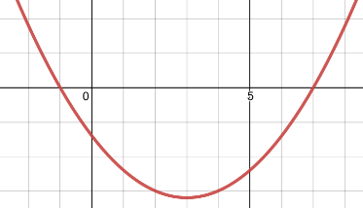

*Example #1* – Find the Zeros of the Function and Graph the Solution Set

a. ${f\left(x\right)=x}^{2}-6x-7$

The equation is: $x^{2}-6x-7=0$, which can be factored (or you could use the quadratic formula):

A graph confirms the intercepts/zeros:

b. $f\left(x\right)=x^{2}+4$

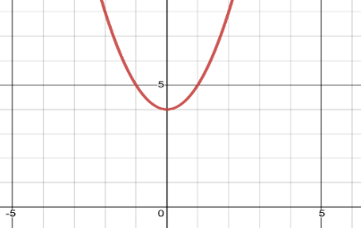

The solution set is complex, meaning there are no REAL zeros/intercepts. A graph confirms that the function does not meet the $x$–axis:

**Topic #7: The Pythagorean Theorem**

The Pythagorean Formula shows the relationship between the legs and hypotenuse of a right triangle and is one of the most widely used formula in all of mathematics:

This shows a right triangle with legs "a" and "b" and hypotenuse "c".
The sum of the squares of the legs is equal to the square of the hypotenuse:
a sqaured plus b squared equals c squared

*Example #1* – Use the Pythagorean Theorem

a. A rectangular park is 8 miles long and 4 miles wide with a hiking trail that runs diagonally across the park. How long is the trail? Write the exact answer and the approximate answer to the nearest tenth.

Draw a picture of the park. Using properties of rectangles, the length and width are the legs and the diagonal is the hypotenuse of a right triangle – use the formula and solve:

*YOU TRY #1:* The base of a 14-foot ladder is 2 feet away from a building. If the ladder reaches the top of the flat roof, how tall is the building? Write the exact answer and the approximate answer to the nearest tenth.

Draw a picture of the ladder; the length of the ladder is the hypotenuse and the other sides are the legs: